Newsletter, October 26th 2020

Dear friends,
I can only report indirectly from Afghanistan. The Kabul colleagues are diligently telephoning me and keeping me up to date.
OFARIN resumed teaching a little before the state schools. Our classes were full. When the state schools started, there was the chaos in Kabul that we are confronted with at the beginning of every school year. State schools need weeks to find their order. Sometimes a class starts in the morning, sometimes in the afternoon, sometimes early in the morning, at 6:00 am. This is changed again and again. When a school has sorted everything so that all classes have their place and time, the municipal school administration intervenes and forces the school to change its plans again.
Most of our students attend both the state schools and OFARIN's classes. It is not made easier by the fact that some of our teachers are also students in the eleventh or twelfth grade of the state school. So most of our students and a significant number of our teachers have to attend the state school at changed times of day every three days. OFARIN tries to adjust our teaching times so that we can keep as many teachers and students as possible. It is precisely at this stage that the Kabul part of OFARIN's program is now in place. This will improve in three weeks. Then, peace and order will return in the state schools; and another three weeks later, the state schools will go on winter vacation for a quarter of a year. In Pandschir and Logar these problems do not exist. There OFARIN's operation runs undisturbed. The pictures on the following pages testify to this.
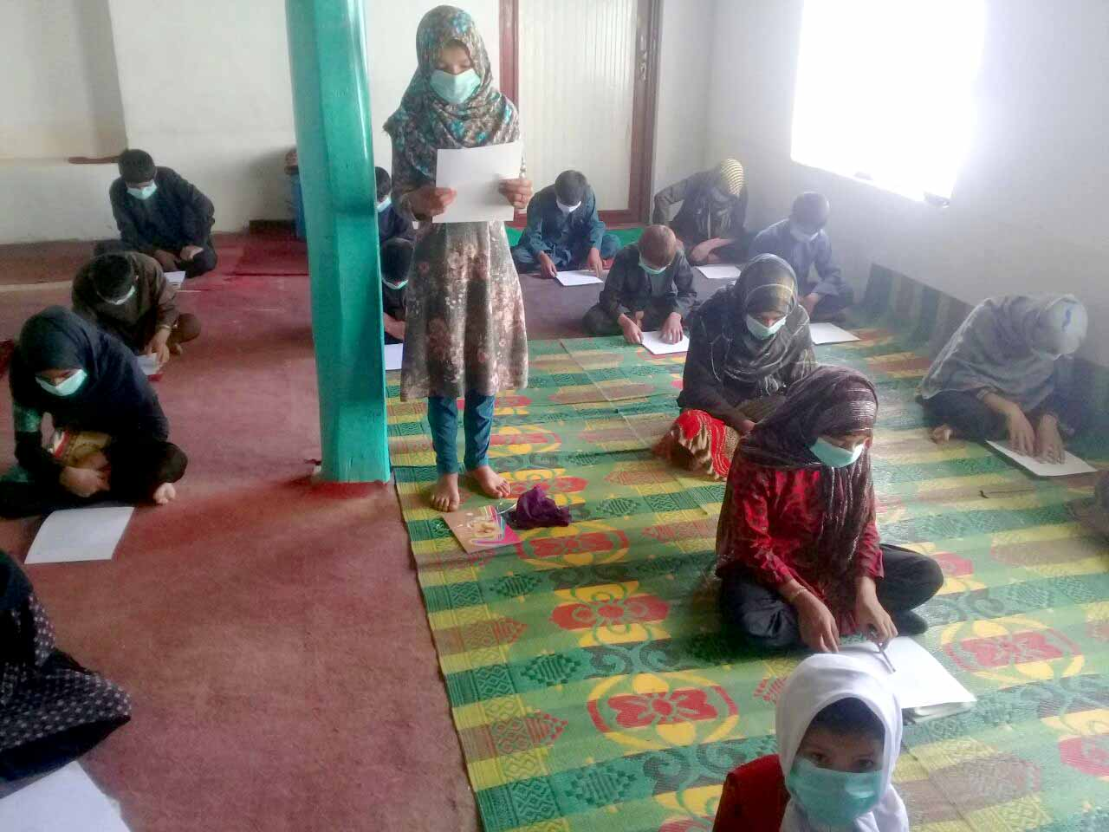
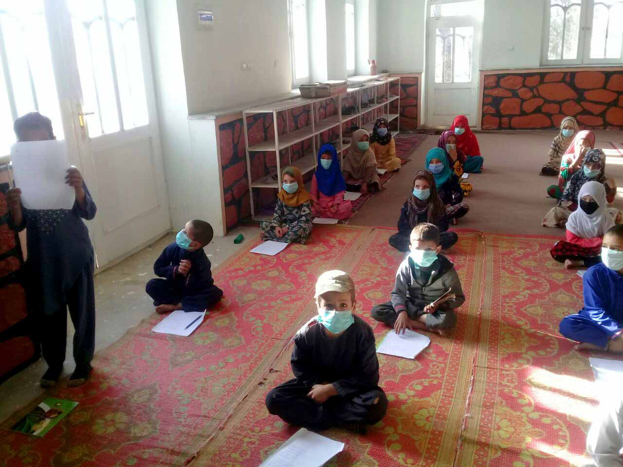
In OFARIN's small mosques in Logar, hygiene regulations are exemplarily kept.
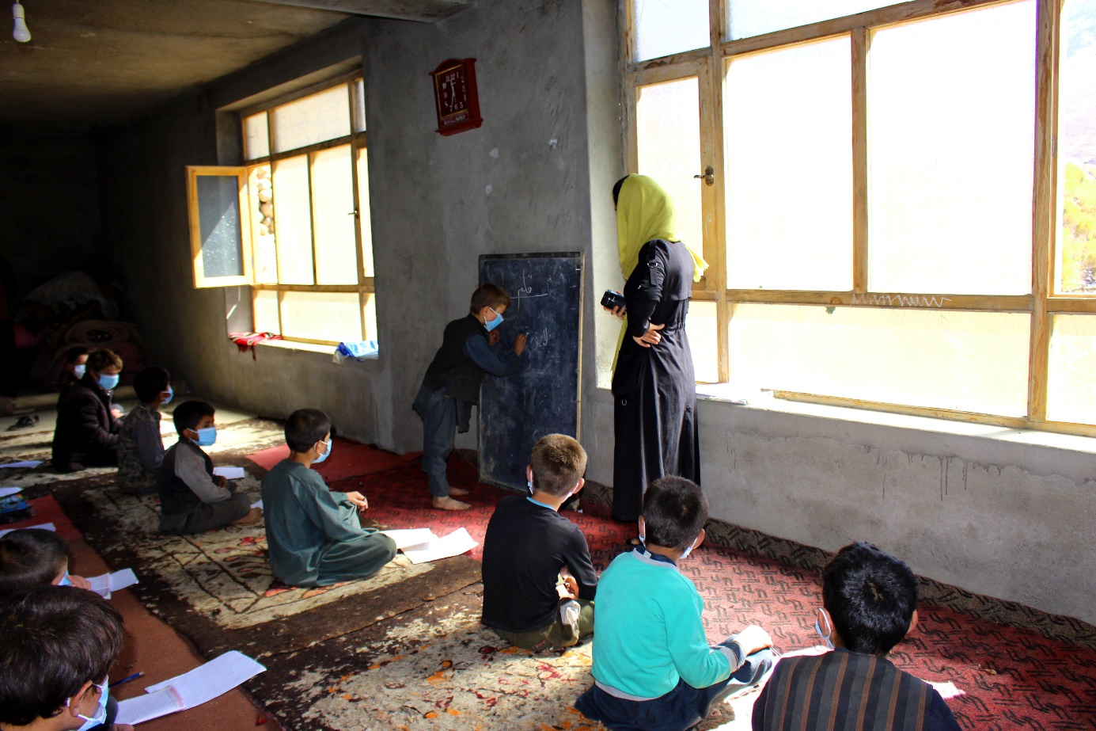
In Paryan in Pandschir, a lady from OFARIN's Kabul office is shown what the students know.
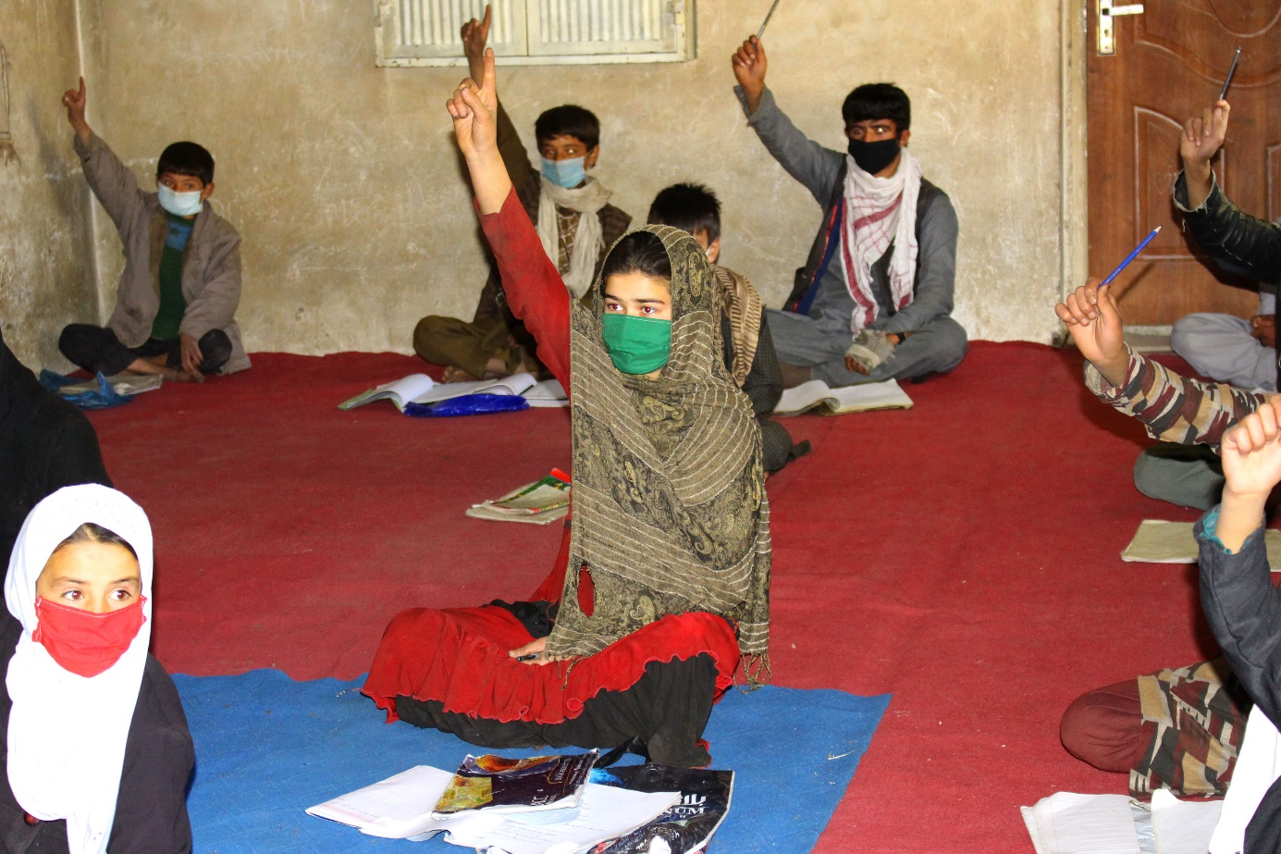
The youth of Paryan wants to show what she can do.
In the Dasht-e-Bartschi district of Kabul, a mullah has proposed to run four classes for adult women together with OFARIN. OFARIN should only provide school books, pencils and notebooks as well as the training and supervision of the teachers. OFARIN should not raise teachers' salaries.
We have already been offered similar cooperation in other areas. Unfortunately, nothing has ever come of it so far. As far as we know, the planned teachers have left because they did not want to work for free or for insecure payments from a mosque community.
After Misereor withdrew as sponsor, more than 50 teachers continued to work, whom we could not pay. The difference to the failed attempts with teachers that we were not supposed to pay is that the good 50 teachers knew OFARIN's lessons, while the others did not know what to do for an uncertain payment. OFARIN's payment for the teachers is modest. In contrast, what they learn through their lessons is a significant personal gain. And also the recognition they enjoy as teachers in their environment is considerable. Teachers who have already worked at OFARIN know this. People, who still consider whether they should get involved in teaching with us, are missing this experience.
At the beginning of their OFARIN career our teachers are very often illiterate. They take over a class to which they teach the alphabet. Step by step they stick to proven teaching material. If the class can read and write, the teacher can do so better than their students. And the same applies to any material the teacher will teach afterwards. We hope thus that the four teachers will overcome the inhibition threshold of the non-payment by OFARIN and will take part.
Unfortunately it is not so that OFARINs program is to be had free of charge, if we change the whole business model over to unpaid teachers. A teacher works only 90 minutes a day with us, which makes his modest salary of currently converted 22 € per month plausible. But without the teaching material we provide, without the textbooks OFARIN produces, without the permanently employed trainers who prepare and then closely supervise the teachers, there would be no efficient teaching. If you also take into account the effort for our office and for the use of the vehicles, you have to calculate 160 € per month for one class.
However, we could cope with the four classes we are talking about without any additional personnel costs. Only pencils and notebooks for the students will be needed. Let's hope for the best!
Our Corona program is running. OFARIN's staff is making inquiries with all teachers and students. If economic hardships have arisen in their families because relatives who contributed to their livelihood have died or because treatment was very expensive, OFARIN pays moderate support. We report about this on the homepage.
Our colleagues have sent a list of all previous recipients of support, including the names of the deceased. For reasons of data protection, we cannot put them in this detail in the homepage. On 18.10., aid of the equivalent of just under 60 € or 120 € was paid out to 17 families, a total of 1,350 €. Some of those affected have not yet been reached by their colleagues. In most cases a one-time help will not be sufficient.

In 1975 I taught at the University of Kabul. At that time Prof. Dr. Erwin Grötzbach visited us. He was an economic geographer at the University of Eichstätt. He had come to Afghanistan to conduct field research. He walked through villages, looked at the dukanes there and counted them. In this way he gained insight into the economic situation. We enjoyed sitting together with him and talking about many things that amazed us in Afghanistan. They were inspiring days.
Prof. Grötzbach went back to Germany. Our paths have never crossed again in the 45 years since then. After all, we had very different fields of work. Now I found an advertisement in a large daily newspaper: Prof. Dr. Erwin Grötzbach had died on October 7th at the age of 87. In the obituary, at the request of Prof. Grötzbach, instead of sending flowers to his funeral, the ad asked him to support a well-functioning (!) project in Afghanistan that was close to his heart, namely that of OFARIN. The bracketed exclamation mark is thus in the advertisement. What a pity about the 45 years that we did not meet again!

Best wishes Peter Schwittek.

Translated with www.DeepL.com/Translator (free version)

